*Please note that I’ve kept all my logs on a computer or a mobile device rather than writing in a notebook by hand.*

**9/2/2017**

Searched for a math-related science fair project idea on Google, and found these resources:

<https://www.sciencebuddies.org/science-fair-projects/Intro-Math.shtml>

<https://www.education.com/science-fair/applied-mathematics/>

<https://cms.math.ca/Education/mpsf/>

<http://mathforum.org/teachers/mathproject.html>

<http://sciencefair.math.iit.edu/projects/>

<http://www.all-science-fair-projects.com/category115.html>

<http://www.juliantrubin.com/mathematicsprojects.html>

<http://www.projects.juliantrubin.com/science_fair_project/highschool/high_school_math.html>

<http://mathforum.org/library/drmath/sets/high_projects.html>

<http://galileo.org/classroom-examples/math/math-fair-problems/>

**9/6/2017**

Focused on geometry-related project ideas as I’m taking geometry at school, and found these resources:

<https://www.sciencebuddies.org/science-fair-projects/project-ideas/Math_p011/pure-mathematics/chain-reaction-inversion-pappus-chain-theorem>

<https://www.sciencebuddies.org/science-fair-projects/project-ideas/Math_p043/pure-mathematics/tiling-with-spidrons>

<https://www.sciencebuddies.org/science-fair-projects/project-ideas/Math_p030/pure-mathematics/topologies>

<https://www.sciencebuddies.org/science-fair-projects/project-ideas/Math_p029/pure-mathematics/data-models>

<https://www.sciencebuddies.org/science-fair-projects/project-ideas/Math_p031/pure-mathematics/fractals>

<https://www.sciencebuddies.org/science-fair-projects/project-ideas/Math_p032/pure-mathematics/origami>

<https://www.sciencebuddies.org/science-fair-projects/project-ideas/Math_p005/pure-mathematics/team-winning-percentage-pythagorean-theorem>

<https://cms.math.ca/Education/mpsf/node6.html#SECTION00060000000000000000>

<http://sciencefair.math.iit.edu/projects/solids/>

<http://mathforum.org/library/drmath/view/53623.html>

<http://galileo.org/classroom-examples/math/math-fair-problems/3d-objects-and-2d-shapes-teachers/>

**9/10/2017**

Decided on my OCSEF project:

<https://www.sciencebuddies.org/science-fair-projects/project-ideas/Math_p011/pure-mathematics/chain-reaction-inversion-pappus-chain-theorem>

**9/14/2017**

Searched for circle inversion and Pappus chain, and found these resources:

<https://www.sciencebuddies.org/science-fair-projects/project-ideas/Math_p011/pure-mathematics/chain-reaction-inversion-pappus-chain-theorem#background>

<https://mathcs.clarku.edu/~djoyce/java/compass/>

<http://mathworld.wolfram.com/Inversion.html>

<http://mathworld.wolfram.com/Arbelos.html>

<http://mathworld.wolfram.com/PappusChain.html>

<http://www.math.tamu.edu/~harold.boas/preprints/arbelos.pdf>

<https://www.cut-the-knot.org/proofs/arbelos.shtml>

<https://www.cut-the-knot.org/Curriculum/Geometry/SymmetryInCircle.shtml>

<https://www.cut-the-knot.org/Curriculum/Geometry/InversionInArbelos.shtml>

<http://www.geometer.org/mathcircles/inversion.pdf>

<http://www.malinc.se/math/noneuclidean/circleinversionen.php>

<http://jwilson.coe.uga.edu/MATH7200/InversionCompanion/inversion/inversionSupplement.pdf>

<http://whistleralley.com/inversion/inversion.htm>

<https://en.wikipedia.org/wiki/Inversive_geometry>

**9/18/2017**

Studied the inversion of a point with respect to an inversion circle:

<http://mathworld.wolfram.com/Inversion.html>

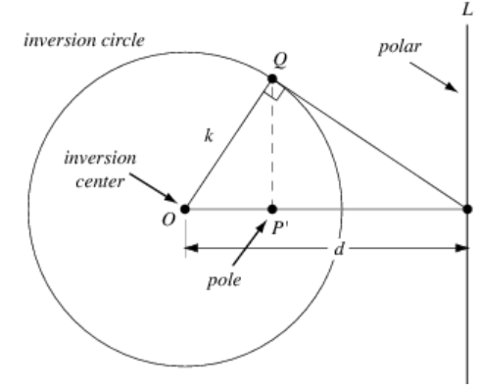

Circle Power:  k^2=OP×OP^' 

Inverse of the point *(x, y)* relative to the inversion circle with inversion center *(x0, y0)* and inversion radius *k*:

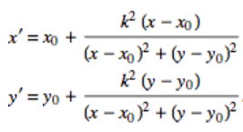

**9/21/2017**

Studied the inversion of a circle with respect to an inversion circle:

<http://mathworld.wolfram.com/Inversion.html>

The inverse of a circle of radius a with center (x,y) with respect to an inversion circle with inversion center (x_0,y_0) and inversion radius k is another circle with center:

|  |  |  |  |
| --- | --- | --- | --- |
| x^' | = | x_0+s(x-x_0) |  |
| y^' | = | y_0+s(y-y_0) |  |

and radius

|  |  |
| --- | --- |
| r^'=|s|a, |  |

where

|  |
| --- |
| s=(k^2)/((x-x_0)^2+(y-y_0)^2-a^2). |

**9/26/2017**

Studied the arbelos and its interesting features:

<http://mathworld.wolfram.com/Arbelos.html>

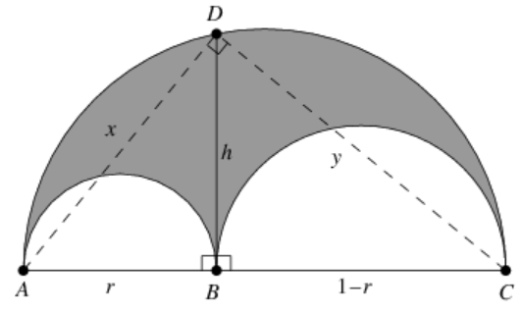

Draw the perpendicular BD from the tangent of the two semicircles to the edge of the large circle. Then the area of the arbelos is the same as the area of the circle with diameter BD.

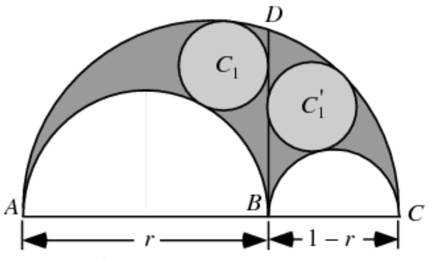

The circles C_1 and C_1^' inscribed on each half ofBD on the arbelos (called Archimedes' circles) each have diameter r(1-r), or radius r(1-r)/2.

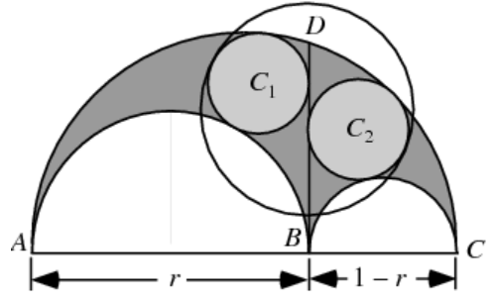

The smallest circumcircle of Archimedes' circles has an area equal to that of the arbelos.

**10/2/2017**

Studied the Pappus chain:

<http://mathworld.wolfram.com/PappusChain.html>

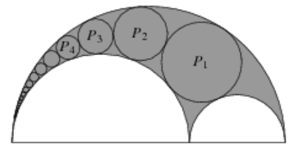

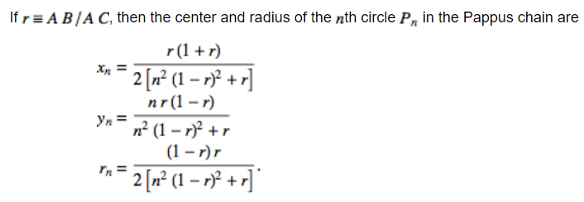

**10/8/2017**

Decided to develop a web page to examine circle inversion. Started learning HTML from:

<https://www.w3schools.com/html/>

<http://htmldog.com/guides/html/beginner/>

<https://www.htmlgoodies.com/primers/html/article.php/3478131>

<https://www.tutorialspoint.com/html/>

**10/19/2017**

Learned how to create the page layout in HTML:

<https://www.w3schools.com/html/html_layout.asp>

**10/22/2017**

Learned how to use textboxes, labels, and buttons in HTML to display data and get user input:

<https://www.w3schools.com/html/html_form_input_types.asp>

**10/26/2017**

Learned about the styles and CSS classes to make the page look nicer:

<https://www.w3schools.com/html/html_css.asp>

**10/30/2017**

Learned about the canvas to draw shapes on:

<https://www.w3schools.com/tags/ref_canvas.asp>

Found out that canvas required JavaScript.

**11/5/2017**

Started learning JavaScript (very similar to Java that I learned over summer):

<http://www.learn-js.org/>

<https://www.w3schools.com/js/>

<https://javascript.info/>

Will use JS to draw shapes and to calculate the positions of those shapes.

**11/17/2017**

Wrote the utility functions to draw a point, line, circle, and semicircle on a canvas.

**11/23/2017**

Wrote an event handler to show the mouse position on the canvas:

<https://stackoverflow.com/questions/23757460/canvas-onclick-coordinates-using-getboundingclientrect-always-the-same>

**11/27/2017**

Wrote the method to invert a point with respect to an inversion circle.

**11/30/2017**

Wrote the method to invert a circle with respect to an inversion circle.

**12/5/2017**

Wrote the method to draw a Pappus chain.

**12/8/2017**

Wrote the method to invert a Pappus chain.

**12/11/2017**

Wrote the templates to load predefined settings to test different scenarios for inversion and Pappus chain.

**12/16/2017**

Added textboxes for the user to enter custom values to invert their own points and circles.

**12/23/2017**

Added a button to show homothety (similarity) between circles in a Pappus chain and their inversions:

<https://www.encyclopediaofmath.org/index.php/Homothety>

**1/7/2018**

Updated the UI design to have a tabstrip because I got tired of scrolling up and down to invert a point, circle, or Pappus chain:

<http://experiments.wemakesites.net/css3-tabstrip.html>

**1/16/2018**

Decided to have three separate canvases (one on each tab) because I kept losing the previous inversion every time I moved from one tab to the other. Besides, every tab had a different height because of the number of template buttons and the canvas position had to be far down below when I had only one.

**1/24/2018**

Searched for a free website hosting company for my web page:

<https://www.weebly.com/features/free-web-hosting>

<https://www.awardspace.com/free-hosting/>

<https://www.freehosting.com/>

Picked weebly because of their easy-to-use interface, blog features, and nice themes.

**2/4/2018**

Completed the website on weebly:

<http://sukarablog.weebly.com/>

Made minor adjustments on the width of several boxes to line them properly.

**2/8/2018**

Started writing the report for my project:

<https://www.ocsef.org/images/resources/Writing_Reports-OCSEF.pdf>

**2/17/2018**

Finished my report.

**2/21/2018**

Started working on my poster board:

<https://www.ocsef.org/images/resources/Science_Fair_Displays-OCSEF.pdf>

**2/26/2018**

Finished my poster board.